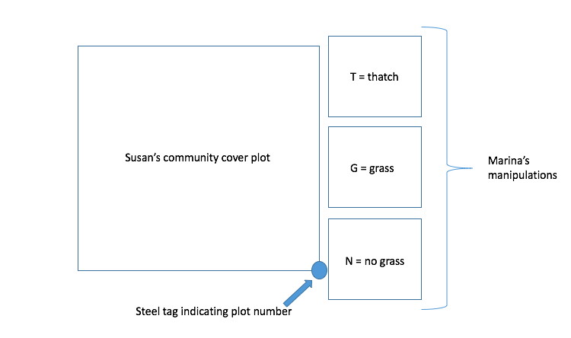Protocol

1. Getting situated
   1. All of the plots I am using are marked with a pink flag. In general flag colors correspond to the treatment
      1. All red flags: watering control plot
      2. 3 red + 1 blue flag: watered plot
      3. White flags: rain-out shelter or shelter control plots
   2. Within each plot are three competition treatments subplots
      1. T = grass thatch (green nails)
      2. G = grass presence (orange nails)
      3. N = no grass (purple nails)
   3. Plots are numbered with a steel tag on the lower right rebar of the main community plot, when you arrive at a plot, check this number to record
   4. 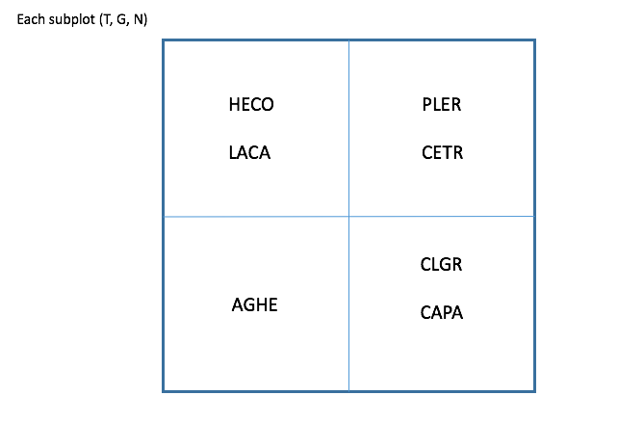Species are seeded into quadrants **within each subplot** to make it a little easier to identify
2. 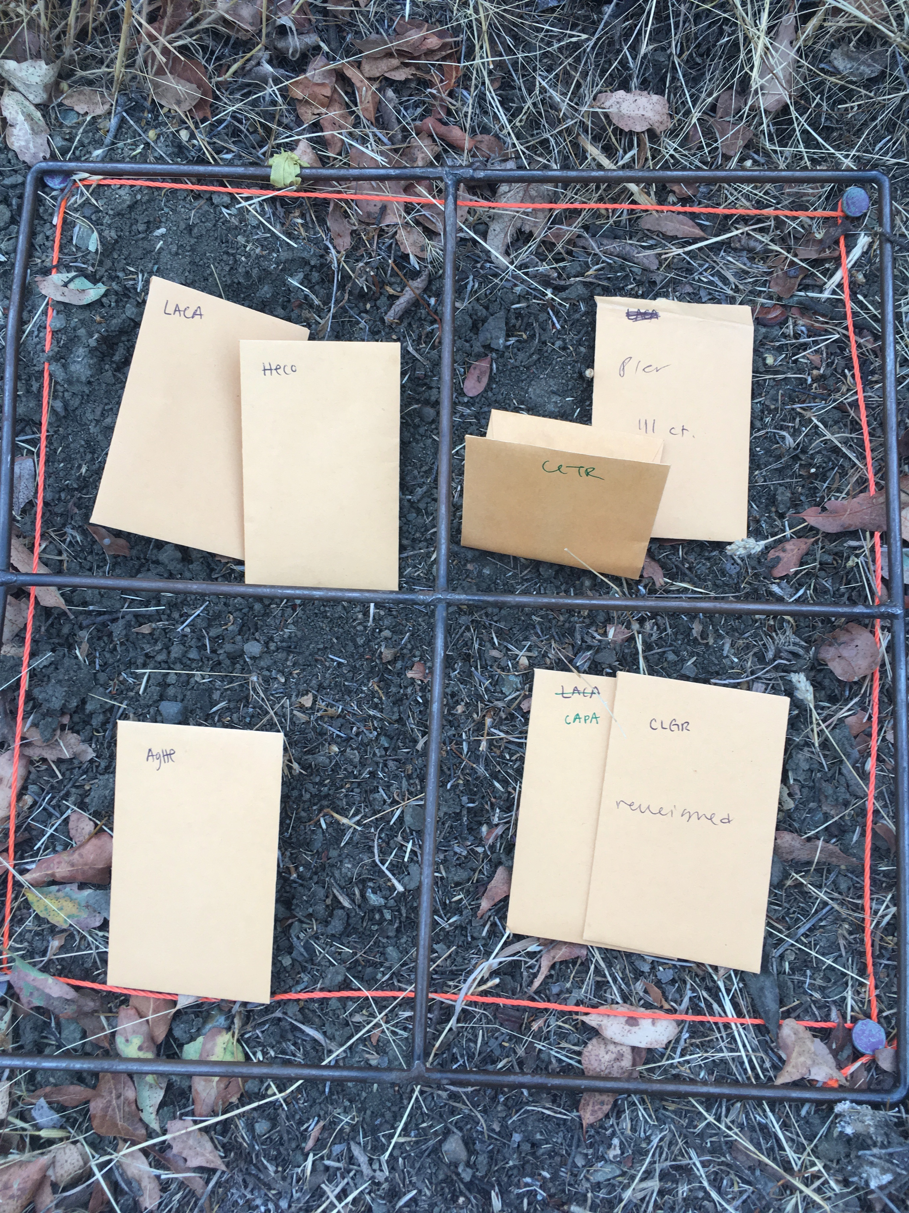Upon arriving at a plot and after checking the plot number
   1. Remove grass and extraneous species from T and N subplots
   2. Remove extraneous species from G subplot
   3. For each species in each subplot
      1. Only tag/record new germs for CETR
      2. Record:
         1. N.germ = number removed + number toothpicked
         2. N.thin = number removed

|  |  |
| --- | --- |
| **Species** | **Toothpick color** |
| Agoseris heterophylla (AGHE) | White |
| Clarkia gracilis (CLGR) | Green |
| Hemizonia congesta (HECO) | Yellow |
| Lasthenia californica (LACA) | Red |
| Centaurium trichanthum (CEGR) | Pink |
| Plantago erecta (PLER) | Orange |
| Calycadenia pauciflora (CAPA) | Blue |

Species Info:

